**ONLINE PROOFING SYSTEM**

This document will guide you on how to use the Online Proofing System.

If there are problems sending the files back into the system or for any other queries, please email the project manager. The email address is indicated in the proof-out email sent to author/editor.

1. Once your paper has been proofed out, you will receive an email from the journal mailbox account.
2. Click “Here” from the email received.

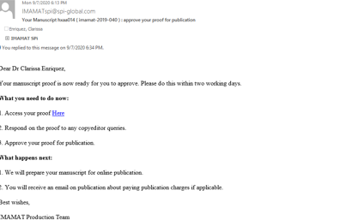

1. You will be directed to a landing page where you can see the link to your proofs.

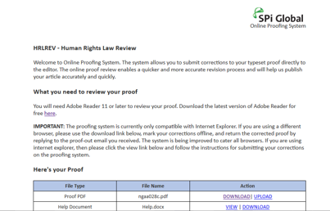

1. Click “Download” and save your proofs in your local drive.

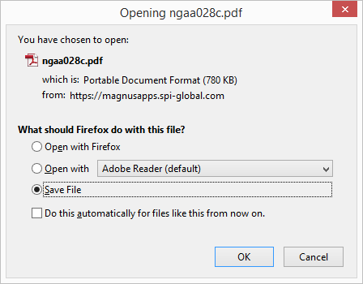

1. Open your proofs using Adobe Acrobat (full version) or Acrobat Reader.

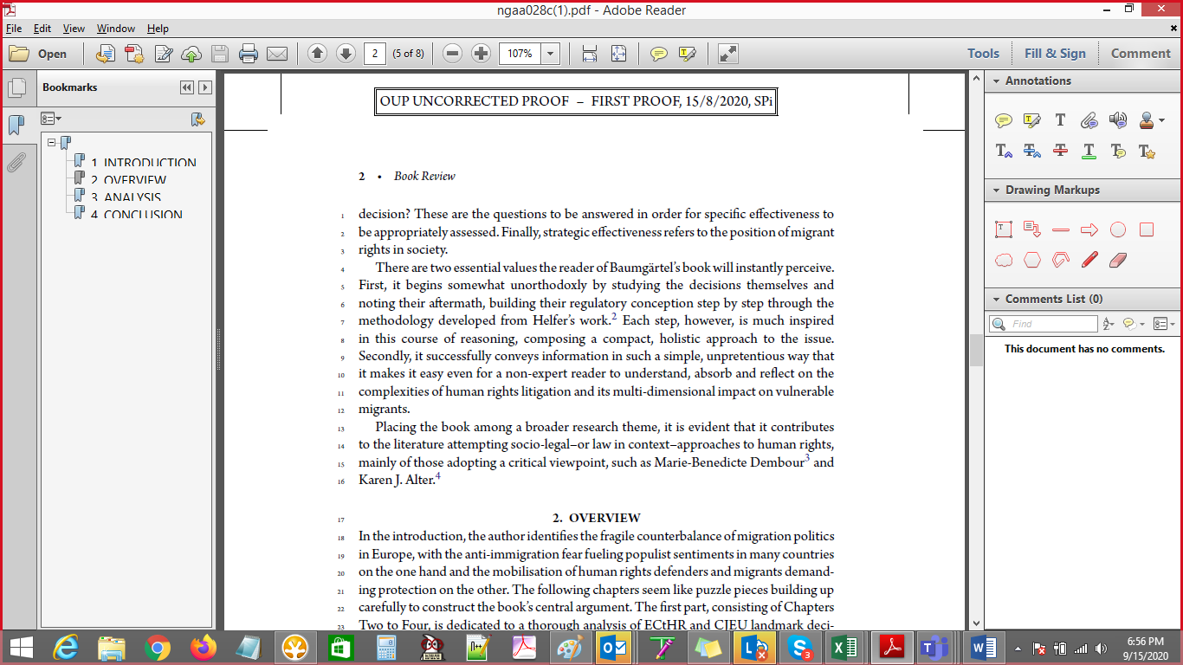

1. Annotate your proofs using the mark-up tools.

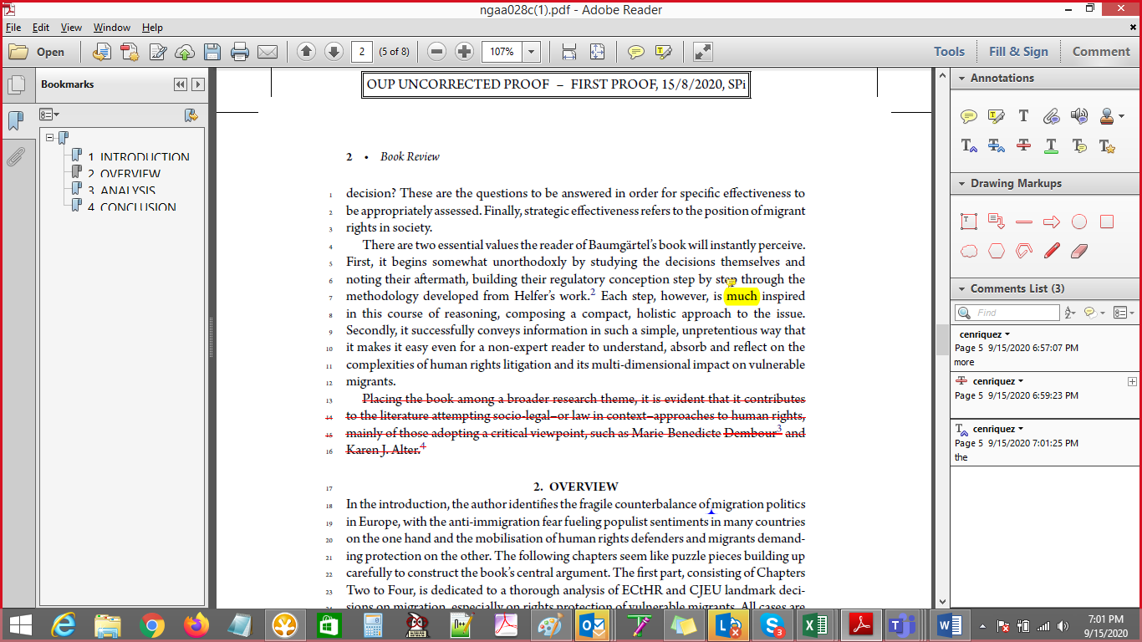

1. Once done, access the landing page again from the link provided in email.
2. Return the annotated proofs using the “Upload” link.



1. Indicate your email address, browse the location of your annotated proofs and click “Save”.

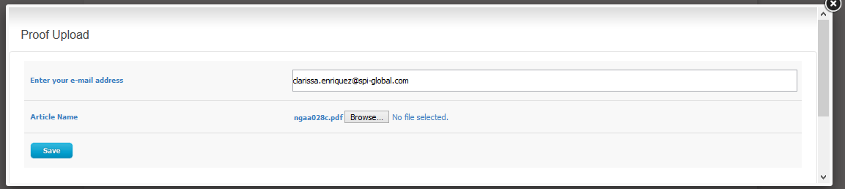

1. The system will inform you of a successful upload of your annotated proofs.

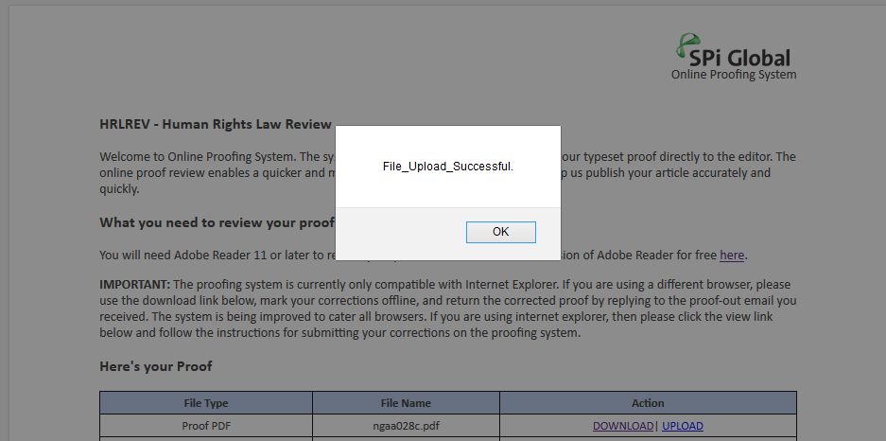

1. You will be notified through email that your corrections were successfully received by the system. Note that this might take a few minutes as this depends on connectivity/latency.

